APPENDIX A
PHOTOGRAPHS TAKEN DURING JIV AT 16” TUNU-BRASS CREEK DELIVERY LINE AT AGBIDIAMA COMMUNITY, EKEREMOR L.G.A, BAYELSA STATE ON 23RD MAY, 2024.
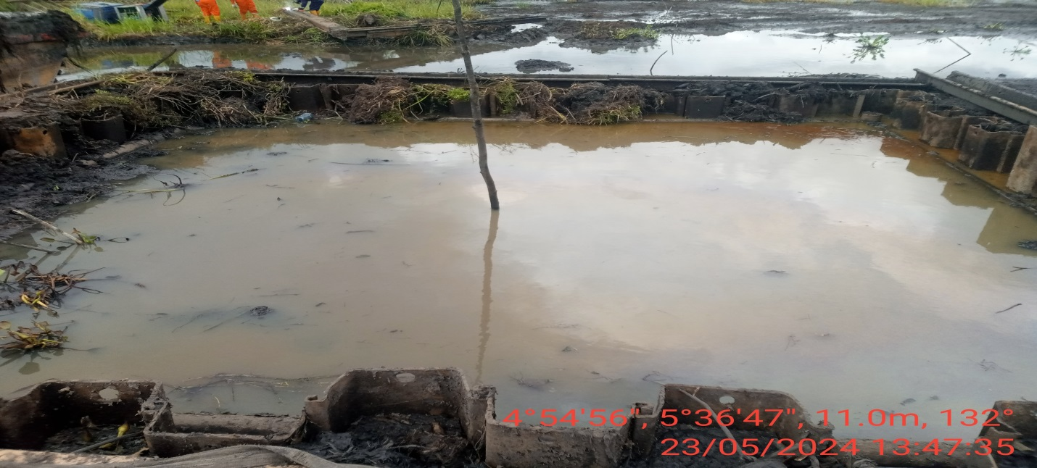
PIC. 1: THE INCIDENT AREA BEFORE EXCAVATION.
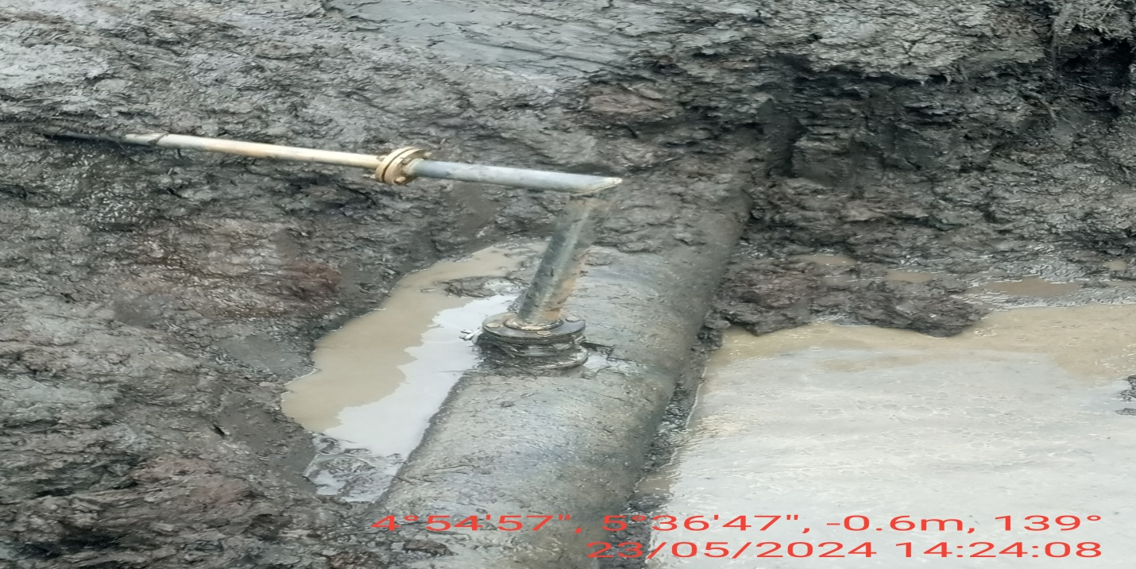
PIC. 2: 3” VALVE WITH 2” PIPE CONNECTION INSTALLED AT 12 O’ CLOCK POSITION OF THE PIPELINE BY UNKNOWN PERSON (S) FOR CRUDE OIL THEFT.

